Experiment-9
Objective : Simulate a transcritical bifurcation in a simple system
Theory : A transcritical bifurcation occurs when two equilibrium points intersect and exchange their stability as a parameter changes. It is typically modeled by $\frac{dx}{dt}=rx-x^{2}$, where stability changes at $r=0$.
Code:
clc;
clear;
close all;

r = linspace(-2, 2, 400);

x1 = zeros(size(r));
x2 = r;

figure;
plot(r, x1, 'r--', 'LineWidth', 2);
hold on;
plot(r, x2, 'b', 'LineWidth', 2);
plot(0, 0, 'ko', 'MarkerSize', 8, 'LineWidth', 2);

xlabel('Bifurcation Parameter r');
ylabel('Equilibrium Points x');
title('Transcritical Bifurcation Diagram');
legend('x = 0 (Unstable → Stable)', ...
'x = r (Stable → Unstable)', ...
'Bifurcation Point');
grid on;

tspan = [0 10];
x0 = 0.5;

r_values = [-1, 0.5, 1];

figure;
hold on;
for r = r_values
f = @(t, x) r*x - x.^2;
[t, x] = ode45(f, tspan, x0);
plot(t, x, 'LineWidth', 2);
end

xlabel('Time t');
ylabel('State x(t)');
title('Time Response Showing Transcritical Bifurcation');
legend('r = -1', 'r = 0.5', 'r = 1');
grid on;

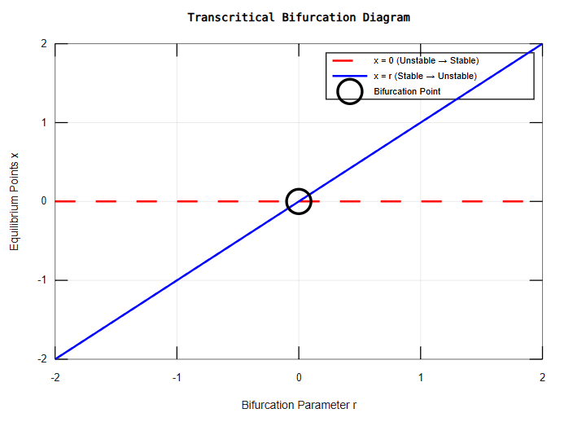
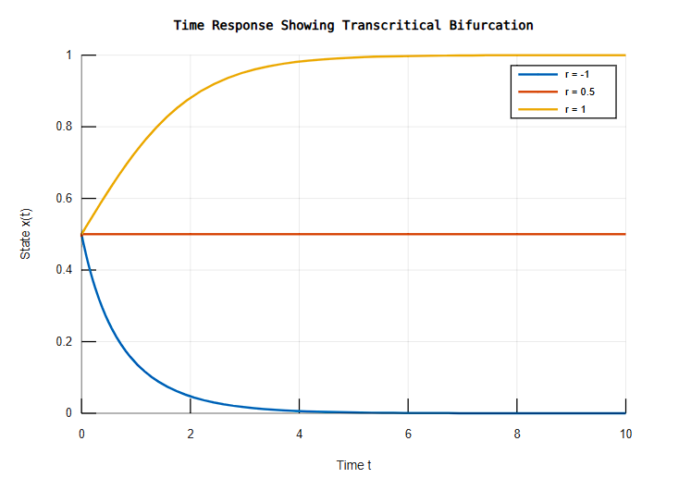
Experiment-2
Objective: Write a program to find the steady-state solution, draw its phase plane plot for the system of ODEs and plot the solution of the system
Theory : A system of differential equations describes the dynamic behavior of variables with respect to time. The steady-state solution is obtained by setting derivatives equal to zero, giving equilibrium points. The phase plane plot represents trajectories of the system, showing stability and the nature of solutions for different initial conditions.
Code:
clc;
clear;
close all;

a = 1; b = -2;
c = 2; d = -1;

f = @(t, X) [a*X(1) + b*X(2);
c*X(1) + d*X(2)];

A = [a b; c d];
steady_state = null(A);
disp('Steady state:');
disp(steady_state);

[x, y] = meshgrid(-5:0.5:5, -5:0.5:5);
dx = a*x + b*y;
dy = c*x + d*y;

figure;
quiver(x, y, dx, dy, 'r');
xlabel('x'); ylabel('y');
title('Phase Plane (Direction Field)');
grid on; axis equal; hold on;

tspan = [0 10];
IC = [1 1; -2 2; 2 -1; -3 -3];

for i = 1:size(IC,1)
[t, sol] = ode45(f, tspan, IC(i,:));
plot(sol(:,1), sol(:,2), 'LineWidth', 2);
end

legend('Direction Field','Trajectories');
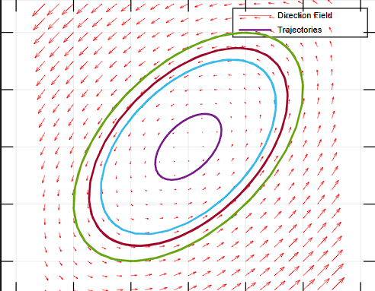

Experiment-3
Obejective: Write a program to find critical points, Jacobian matrix, eigen values and eigen vectors of system of differential equations with constant coefficients
Theory : Critical points of a system are obtained by setting derivatives equal to zero. The Jacobian matrix and its eigenvalues determine the stability and nature of these points
Code:
clc;
clear;
close all;

a=1; b=-2; c=2; d=-1;

f=@(t,X)[a*X(1)+b*X(2); c*X(1)+d*X(2)];

A=[a b; c d];

crit=null(A);
disp('Critical Points:'); disp(crit);

J=A;
disp('Jacobian Matrix:'); disp(J);

[V,D]=eig(A);
disp('Eigen Values:'); disp(diag(D));
disp('Eigen Vectors:'); disp(V);

[x,y]=meshgrid(-5:0.5:5,-5:0.5:5);
dx=a*x+b*y; dy=c*x+d*y;

figure;
quiver(x,y,dx,dy); hold on;

tspan=[0 10];
IC=[1 1;-2 2;2 -1;-3 -3];

for i=1:size(IC,1)
[t,sol]=ode45(f,tspan,IC(i,:));
plot(sol(:,1),sol(:,2),'LineWidth',2);
end

xlabel('x'); ylabel('y');
title('Phase Plane with Trajectories');
grid on; axis equal;

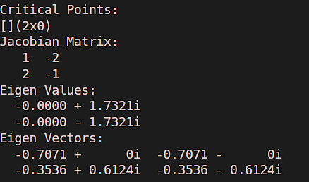

Experiment-4
Objective:Develop a MATLAB function to check the stability of a linear system using the Routh-Hurwitz criterion
Theory : The characteristic equation is
$$a_{n}s^{n}+a_{n-1}s^{n-1}+⋯+a_{0}=0$$The Routh-Hurwitz criterion determines the stability of a system without solving for the roots. A Routh array is constructed using the coefficients of the equation. If all the elements of the first column are positive, the system is stable.
Code:
clc;
clear;
close all;

coeff = [1 4 6 4 1];

n = length(coeff);
m = ceil(n/2);

R = zeros(n,m);

R(1,1:m) = coeff(1:2:end);
R(2,1:length(coeff(2:2:end))) = coeff(2:2:end);

for i=3:n
for j=1:m-1
R(i,j) = (R(i-1,1)*R(i-2,j+1)-R(i-2,1)*R(i-1,j+1))/R(i-1,1);
end
end

disp('Routh Array:');
disp(R);

if all(R(:,1)>0)
disp('System is Stable');
else
disp('System is Unstable');
end

p = roots(coeff);

figure;
plot(real(p),imag(p),'x','LineWidth',2);
xlabel('Real'); ylabel('Imaginary');
title('Root Location Plot');
grid on;

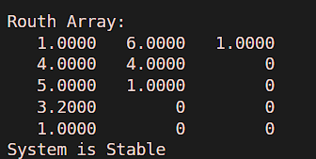

Experiment-5
Obejctive :Write a program to check the stability of a linear system using the Lyapunov function
Theory:Lyapunov’s method determines stability using a positive definite function. If its derivative is negative definite, the system is stable.
Code:
clc;
clear;
close all;

A = [1 -2; 2 -3];

Q = eye(2);

P = lyap(A', Q);

disp('Lyapunov Matrix P:');
disp(P);

e = eig(P);

if all(e > 0)
disp('System is Stable');
else
disp('System is Unstable');
end

[x,y] = meshgrid(-5:0.5:5,-5:0.5:5);
dx = A(1,1)*x + A(1,2)*y;
dy = A(2,1)*x + A(2,2)*y;

figure;
quiver(x,y,dx,dy); hold on;

tspan = [0 10];
IC = [1 1; -2 2; 2 -1; -3 -3];

f = @(t,X)[A(1,1)*X(1)+A(1,2)*X(2); A(2,1)*X(1)+A(2,2)*X(2)];

for i=1:size(IC,1)
[t,sol] = ode45(f,tspan,IC(i,:));
plot(sol(:,1),sol(:,2),'LineWidth',2);
end

xlabel('x'); ylabel('y');
title('Lyapunov Stability Phase Plot');
grid on; axis equal;
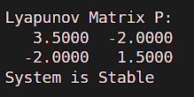

\
Experiment-6
Objective:Simulate the Lotka-Volterra prey-predator model and analyze the population dynamics over time.
Theory:The Lotka-Volterra model describes the interaction between prey and predator populations using nonlinear differential equations. The prey population grows exponentially in absence of predators, while predators depend on prey for survival. The model shows oscillatory behavior representing cyclic population dynamics.
Code:
clc;
clear;
close all;

alpha=1; beta=0.5; delta=0.5; gamma=2;

f=@(t,X)[alpha*X(1)-beta*X(1)*X(2); delta*X(1)*X(2)-gamma*X(2)];

tspan=[0 20];
X0=[10 5];

[t,X]=ode45(f,tspan,X0);

figure;
plot(t,X(:,1),'b','LineWidth',2); hold on;
plot(t,X(:,2),'r','LineWidth',2);
xlabel('Time'); ylabel('Population');
title('Prey-Predator Dynamics');
legend('Prey','Predator');
grid on;

figure;
plot(X(:,1),X(:,2),'k','LineWidth',2);
xlabel('Prey'); ylabel('Predator');
title('Phase Plot');
grid on;

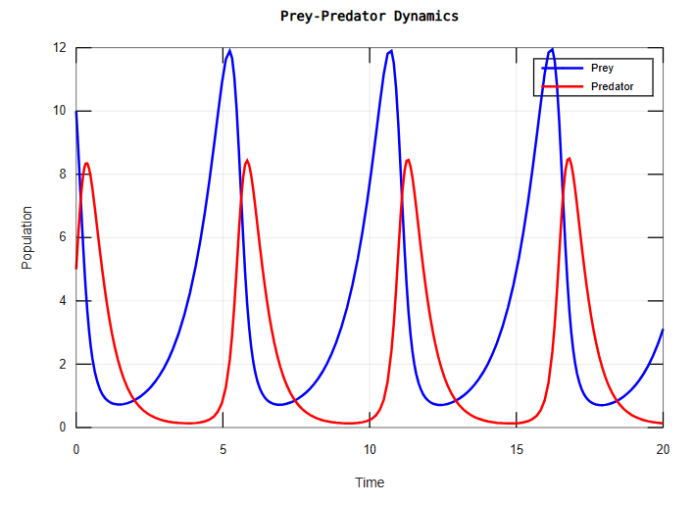
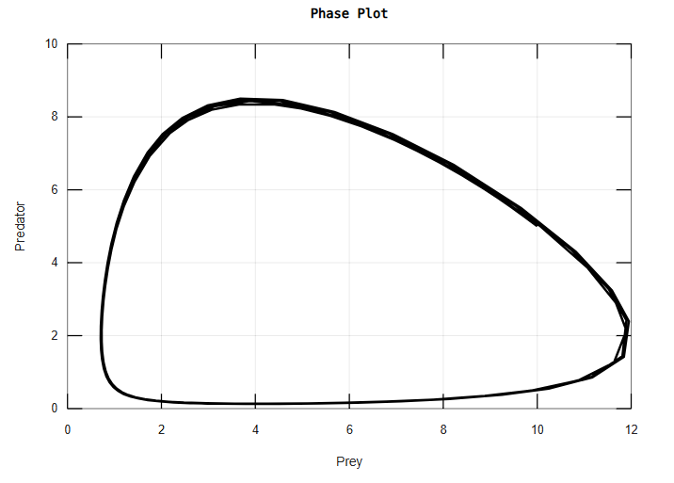

Experiment-7
Objective : Implement the SIR model for an epidemic and analyze how varying parameters (infection rate, recovery rate) affect the spread of disease
Theory: The SIR model divides the population into susceptible, infected, and recovered groups. The infection rate controls how quickly the disease spreads, while the recovery rate determines how fast individuals recover. The model helps analyze epidemic dynamics and predict peak infection levels
Code:
clc;
clear;
close all;

beta=0.5; gamma=0.1;

f=@(t,X)[-beta*X(1)*X(2); beta*X(1)*X(2)-gamma*X(2); gamma*X(2)];

tspan=[0 50];
X0=[0.9 0.1 0];

[t,X]=ode45(f,tspan,X0);

figure;
plot(t,X(:,1),'b','LineWidth',2); hold on;
plot(t,X(:,2),'r','LineWidth',2);
plot(t,X(:,3),'g','LineWidth',2);
xlabel('Time'); ylabel('Population');
title('SIR Model');
legend('Susceptible','Infected','Recovered');
grid on;

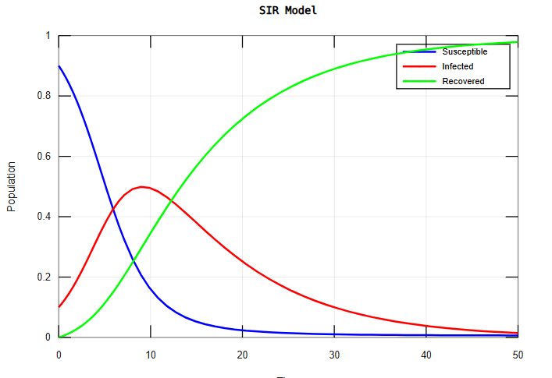

Experiment-8
Objective:Simulate and analyze the saddle-node bifurcation in a simple dynamical system.
Theory :A saddle-node bifurcation occurs when two equilibrium points collide and annihilate each other as a parameter changes. It is commonly represented by $\frac{dx}{dt}=r+x^{2}$. At the bifurcation point, the system transitions from having no equilibrium to two equilibria
Code:
clc;
clear;
close all;

r=linspace(-2,2,400);

x1=sqrt(r);
x2=-sqrt(r);

x1(r<0)=NaN;
x2(r<0)=NaN;

figure;
plot(r,x1,'b','LineWidth',2); hold on;
plot(r,x2,'r','LineWidth',2);
plot(0,0,'ko','LineWidth',2);
xlabel('r'); ylabel('x');
title('Saddle-Node Bifurcation');
legend('x=+√r','x=-√r','Bifurcation Point');
grid on;

tspan=[0 3];
x0=0.5;
r_values=[-1 0];

opts=odeset('MaxStep',0.01);

figure; hold on;

for r=r_values
f=@(t,x) r+x.^2;
[t,x]=ode45(f,tspan,x0,opts);
plot(t,x,'LineWidth',2);
end

xlabel('t'); ylabel('x(t)');
title('Time Response');
legend('r=-1','r=0');
grid on;

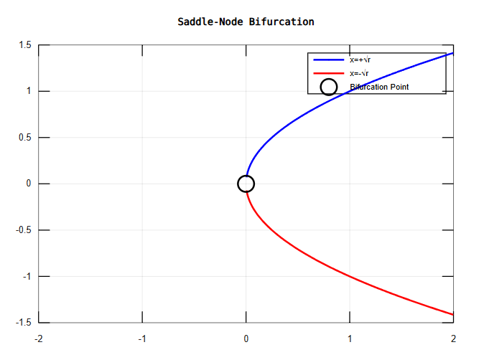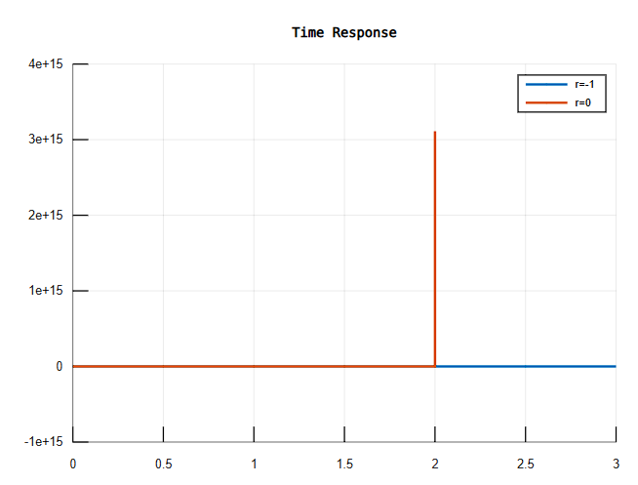
Experiment-10
Objective :Simulate the chaotic behavior of the Lorenz system.
Theory :The Lorenz system is a set of nonlinear differential equations that exhibits chaotic behavior for certain parameter values. It is highly sensitive to initial conditions, leading to unpredictable long-term behavior. The system produces a strange attractor, representing deterministic chaos
Code:
clc;
clear;
close all;

sigma=10; rho=28; beta=8/3;

f=@(t,X)[sigma*(X(2)-X(1)); X(1)*(rho-X(3))-X(2); X(1)*X(2)-beta*X(3)];

tspan=[0 50];
X0=[1 1 1];

[t,X]=ode45(f,tspan,X0);

figure;
plot3(X(:,1),X(:,2),X(:,3),'LineWidth',1.5);
xlabel('x'); ylabel('y'); zlabel('z');
title('Lorenz Attractor');
grid on;
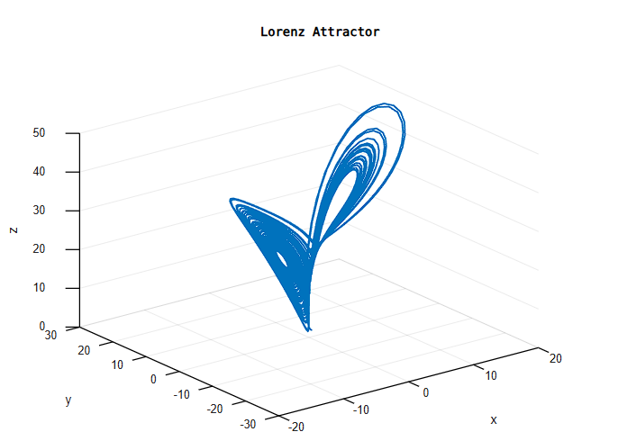

Experiment-1
Objective:Write a program to draw direction fields for the system of differential equations with constant coefficients.
Theory: A direction field (or slope field) is a graphical representation used to visualize the solutions of a system of differential equations without needing to solve them analytically.
$$\frac{dx}{dt}=ax+by \\ \frac{dy}{dt}=cx+dy$$
The variables $x$and $y$represent the state of the system. the equations give the rate of change $\left(dx/dt , dy/dt\right)$.
Code;
clc;
clear;
close all;

a=1; b=-2; c=2; d=-1;

[x,y]=meshgrid(-5:0.5:5,-5:0.5:5);

dx=a*x+b*y;
dy=c*x+d*y;

figure;
quiver(x,y,dx,dy);
xlabel('x'); ylabel('y');
title('Direction Field');
grid on; axis equal;

f=@(t,X)[a*X(1)+b*X(2); c*X(1)+d*X(2)];

tspan=[0 10];
IC=[1 1;-2 2;2 -1;-3 -3];

hold on;
for i=1:size(IC,1)
[t,sol]=ode45(f,tspan,IC(i,:));
plot(sol(:,1),sol(:,2),'LineWidth',2);
end
